SIMPLE CHECKMATES (Part 2)
4. Checkmate with a Queen:
The first step is to drive opposing King to the edge of the board, and this can be done using the Queen alone. To do this, the Queen does not give check but stand forming an L-shape distance with opposing King.
The second step is to bring your King over to help Queen delivers checkmate.

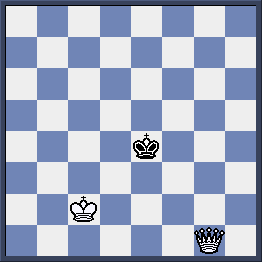
With the first move 1.Qf2 White Queen forms an L-shape distance to Black King. Game continues 1…Kd5 2.Qe3 Kd6 3.Qe4 Kc5 4.Qd3 Kc6 5.Qd4 Kc7 6.Qd5 Kc8 7.Qd6 Kb7 8.Qc5 Ka6 9.Qb4

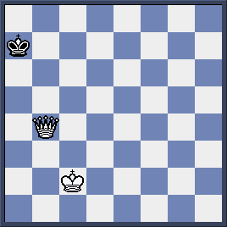
Black King is confined to the a-file, now it is time to bring White King to c7 to support the checkmate.
10. Kc3 Ka6 11.Kc4 Ka7 12.Kc5 Ka8 13.Kc6 Ka7 14.Qb7#

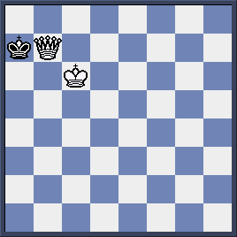

Quiz: Can you deliver mate in 2 moves?
………………………………..
………………………………..

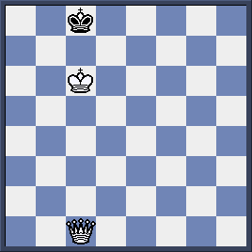

5. Checkmate with a Rook:

We also have to drive the opposing King to the edge of the board but it is a harder task as a Rook cannot do it alone like a Queen. Our King has to combine well with Rook to do that.
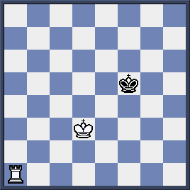

1. Re1! (To cut off Black King half a board, also playable is 1. Ra4 cutting the 4th rank) 1…Kf4 2.Re3! (To control 3rd rank) 2…Kf5 3.Re4 Kf6 4. Kd4 (King moves forward) Kf5 5. Kd5 Kf6 6.Re5! Kg6 7.Ke6! (King gains ground) 7… Kg7 8. Rg5+ Kh6 (8…Kf8 9.Rg4! Ke8 10.Rg8#) 9.Kf6 Kh7 10.Rg6! Kh8 11.Kf7 (not 11.Rg7?? stalemate-draw) Kh7 12.Rf6 Kh8 13.Rh6#
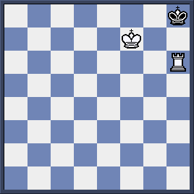

Quiz:
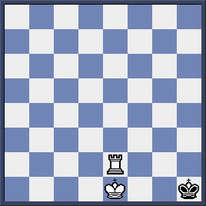

White is to checkmate in 3 moves.
1.-----------------
2.------------------
3.--------------------

